IT Ticket analysis

By Saketh Reddy

# Subjective Questions

1. If there is an investment, should it be used to hire more IT agents, improve training programs, or upgrade ticket management software?

Analysis: Perform a cost-benefit analysis using ticket resolution and satisfaction metrics. Ans:

# Approach

* + 1. **Hiring IT Agents:** Analyze average ticket count per agent, resolution times, and satisfaction scores to measure workload distribution and identify staffing gaps.
    2. **Improving Training Programs:** Compare satisfaction-to-resolution time ratios across agents to identify skill gaps and improvement areas.
    3. **Upgrading Ticket Software:** Assess alignment between severity and priority of tickets. Look for mismatches (e.g., high-severity tickets assigned as normal priority) that indicate inefficiencies in categorization and workflow.

# Key Insights

* **Hiring IT Agents**
  + Ticket volume doubled from 13,051 (2016) to 29,088 (2020), yet resolution time stayed around 4.5–4.6 days.
  + Top agents (e.g., Agents 2, 8, 15, 17) resolve faster (3.6–3.8 days) with higher

satisfaction (4.3–4.5), but underperformers (Agents 19, 22, 3) show slower times

(5.0–5.5 days) and lower satisfaction (3.0–3.6).

* + Rising workload is unevenly distributed, leading to stress and performance drops for some agents.

# Improving Training Programs

* + Satisfaction-to-resolution ratios show that skilled agents deliver better outcomes with less time, while weaker agents take longer and still score low in satisfaction
  + This indicates training gaps and need for knowledge-sharing.
  + Without targeted training, underperformers will continue to lag despite overall staffing levels.

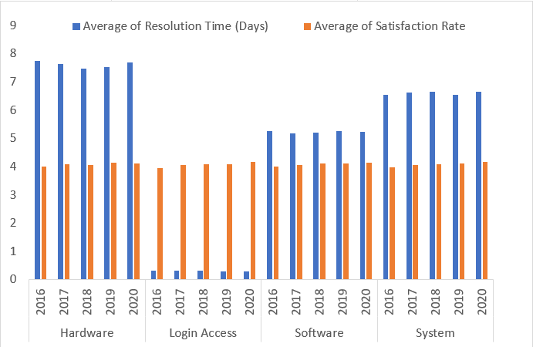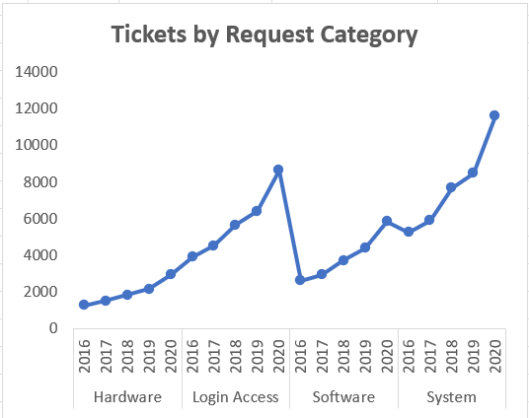

# Upgrading Ticket Software

* + ~90% tickets fall under Normal category making it into dominant.
  + High-priority is overloaded (32k), even for tickets marked as only Normal severity.
  + Urgent severity tickets (1.3k) also face mismatch as 409 unassigned and 169 low priority, risking delays.
  + Severity–priority mapping is inconsistent, proving that ticket management rules are weak or outdated..

|  |  |  |  |  |  |
| --- | --- | --- | --- | --- | --- |
| **Count of ID Ticket** | **PRIORITY** |  |  |  |  |
| **SEVERITY** | **0 - Unassigned** | **1 -**  **Low** | **2 -**  **Mid** | **3 -**  **High** | **Grand**  **Total** |
| 0 - Unclassified | 115 | 80 | 55 | 106 | 356 |
| 1 - Minor | 626 | 549 | 407 | 676 | 2258 |
| 2 - Normal | 26826 | 15282 | 14468 | 32080 | 88656 |
| 3 - Major | 1434 | 614 | 713 | 2075 | 4836 |
| 4 - Urgent | 409 | 169 | 202 | 612 | 1392 |
| **Grand Total** | **29410** | **16694** | **15845** | **35549** | **97498** |

4 - Urgent

3 - Major

2 - Normal

1 - Minor

0 - Unclassified

20000

15000

10000

5000

0

3 - High

25000

1. - Low
2. - Mid

30000

0 - Unassigned

35000

**Conclusion**

* + Hiring IT Agents helps reduce workload pressure as ticket volumes keep increasing, but hiring alone will not fix uneven performance.
  + Training Programs are essential to bring underperformers closer to top agents, improving satisfaction without extra cost of staffing.
  + Ticket Software Upgrade is critical, as poor categorization and priority-severity mismatches are creating hidden bottlenecks that staffing and training alone ca

# Recommendations

**Training:** Launch targeted training for underperforming agents, with mentorship from high-performing agents. Focus on improving resolution speed and communication quality.

**Hiring:** Recruit additional IT agents to balance rising ticket volumes and reduce pressure on current staff, especially during peak workloads.

**Software Upgrade**: Upgrade ticket management software with stronger automation and rules to ensure severity aligns with priority. This will reduce misclassification and speed up urgent case handling.

**Performance Tracking:** Continuously monitor satisfaction scores, resolution times, and priority-severity mapping to measure improvements after each intervention.

1. Which agents need additional training based on their performance metrics?

Analysis: Identify agents with the lowest satisfaction ratings and longest resolution times. Ans:

# Approach

The analysis identified agents needing training based on:

* **Key Metrics:** High resolution times and satisfaction scores below 4.0 indicate inefficiency and poor user experience.
* **Performance Thresholds:** Target resolution time is 4.6 days, with satisfaction scores above 4.0.
* **Segmentation:** Agents with both high-resolution times and low satisfaction were prioritized.

# Insights

Agents 19, 3, 6, 7, 22, 25, and 28 need targeted training to address high resolution times and low satisfaction scores, with Agent 19 requiring urgent intervention. High-performing agents like 14, 18, 26, 30, and 41 can act as mentors to foster best practices, while process reviews and performance incentives can drive overall improvement.

# Conclusion

Agents 19, 3, 6, 7, 22, 25, and 28 require targeted training to improve

performance, with Agent 19 needing the most attention. Agents 14, 18, 26, 30, and 41 demonstrate consistent excellence and can serve as mentors.

# Recommendations

* **Training:** Conduct technical skill sessions and customer service workshops to address long resolution times and low satisfaction scores.
* **Monitoring:** Regularly track agent performance and provide feedback to address weaknesses promptly.
* **Mentorship:** Pair underperforming agents with high-performing peers to share best practices.
* **Process Review:** Evaluate tools and workflows used by underperformers to identify and remove bottlenecks.
* **Incentives:** Recognize and reward agents who make significant performance improvements to encourage growth.

|  |  |  |
| --- | --- | --- |
| **Agent Id** | **Average Resolution Time** | **Average Satisfaction Rate** |
| 3 | 5.381989114 | 3.615042058 |
| 6 | 5.32067727 | 3.592611596 |
| 7 | 5.524031008 | 3.97622739 |
| 11 | 4.778118609 | 3.63803681 |
| 14 | 4.901132853 | 4.085478888 |
| 18 | 4.731501057 | 3.991014799 |
| 19 | 4.999495968 | 3.04233871 |
| 22 | 5.511190234 | 3.628179044 |
| 25 | 5.204616999 | 3.601259182 |
| 26 | 4.754457463 | 3.990830362 |
| 28 | 5.409558068 | 3.612024666 |
| 30 | 4.867040245 | 3.847682119 |
| 33 | 4.804392237 | 3.631256384 |
| 37 | 4.595028483 | 3.660797514 |
| 41 | 4.554933876 | 3.783316378 |

1. Do certain categories of requests have longer resolution times? Analysis: Analyze the resolution times by request category.

Ans:

# Approach

The analysis examines resolution times across request categories to identify inefficiencies and their impact on IT support performance. Steps included segmenting categories, comparing resolution times, assessing impacts, and proposing strategies for improvement.

# Insights

* **Longest Resolution Times:** Hardware (7.6 days) and System (6.6 days) face delays due to diagnostic challenges, resource limitations, and dependencies.
* **Moderate Resolution Time:** Software requests (5.2 days) exceed the overall average of 4.6 days due to inefficiencies like bugs and compatibility issues.
* **Fastest Resolution Time:** Login Access (0.3 days) achieves excellent efficiency through straightforward processes or automation.
* **Overall Impact:** Categories like Hardware and System significantly increase the average resolution time, impacting overall efficiency and satisfaction.

# Conclusion

Hardware (7.6 days) and System (6.6 days) have notably higher resolution times, while Software (5.2 days) also requires optimization. Prolonged resolution in these categories can delay responses, create backlogs, and reduce satisfaction, despite Login Access being highly efficient.

# Recommendations

* **Specialized Tools and Automation:** Invest in diagnostic tools and vendor partnerships for Hardware, and AI-powered monitoring for System issues.
* **Optimize Software Handling:** Train agents, enhance access to developers, and leverage knowledge bases for common issues.
* **Performance Monitoring:** Set category-specific targets and track trends to address recurring bottlenecks.
* **Adopt Best Practices:** Apply the efficiencies of Login Access processes to other categories where feasible.
* **Workload Distribution:** Dedicate specialized teams to Hardware and System categories to improve resolution efficiency.

Implementing these steps can streamline complex ticket handling, reduce resolution times, and boost overall satisfaction.

Resolution time by Request Category

10.00

8.00

6.00

4.00

2.00

0.00

Hardware

Login Access

Software

System

1. How effective are the current software tools in managing IT tickets?

Analysis: Evaluate performance metrics before and after the implementation of new tools.

Ans:

# Approach

* + 1. Analyze resolution times by request category (Hardware, Login Access, Software, System).
    2. Compare satisfaction rates across categories to identify consistency and user expectations.
    3. Evaluate ticket severity-to-priority alignment to check software effectiveness in categorization and escalation.

# Insights

* **Resolution Times**
  + Login Access tickets are resolved very quickly (0.3 days), showing strong tool efficiency for simple issues.
  + Hardware (7.6 days), System (6.6 days), and Software (5.2 days) show significant delays, highlighting weaknesses in managing complex issues.

# Satisfaction Rates

* + Despite large differences in resolution time, satisfaction scores remain steady at ~4.1 across categories.
  + This suggests users adjust expectations: they tolerate delays for

complex categories but remain satisfied if issues are eventually resolved well.

# Performance Gaps

* + Tools are effective for simple/low-complexity requests but struggle with complex categories (Hardware and System).
  + ~90% of tickets are marked "Normal," masking critical issues.
  + 409 Urgent and 1,434 Major tickets remain unassigned priority → clear inefficiency in ticketing software.
  + Severity not consistently mapped to Priority, delaying resolution of high- impact cases.

# Conclusion

Current tools perform well for simple issues (Login Access) but are less effective in handling complex categories like Hardware and System. Stable satisfaction rates show users value quality over speed, but software inefficiencies in categorization and priority assignment reduce overall effectiveness.

# Recommendations

1. **Specialized Tools:** Invest in advanced tools or AI diagnostics for Hardware and System categories to reduce resolution delays.
2. **Training & Collaboration**: Provide targeted training and encourage collaboration with software/system teams to speed up problem- solving.
3. **Improve Categorization:** Redesign ticketing rules to ensure severity correctly maps to priority, reducing misclassification.
4. **Automation & Self-Service:** Expand automation for diagnostics and self-service portals for common issues, freeing agents for complex tasks.
5. **Satisfaction Enhancement:** Conduct surveys and improve first- response speed to maintain user trust while reducing waiting times.
6. **Performance Monitoring:** Track resolution time and satisfaction by category, and review priority-severity mapping monthly to ensure alignment.

|  |  |  |
| --- | --- | --- |
|  | **Average of Resolution Time (Days)** | **Average of Satisfaction Rate** |
| **Request Category** |  |
| Hardware | 7.63 | 4.10 |
| Login Access | 0.31 | 4.09 |
| Software | 5.24 | 4.11 |
| System | 6.62 | 4.10 |
| **Grand Total** | **4.55** | **4.10** |

4 - Urgent

3 - Major

2 - Normal

0 - Unclassified 1 - Minor

20000

15000

10000

5000

0

3 - High

25000

1. - Unassigned
2. - Low
3. - Mid

35000

30000

**612**

**202**

**169**

**409**

**2075**

**713**

**614**

**1434**

**32080**

**14468**

**15282**

**26826**

**676**

**407**

**549**

**626**

**106**

**55**

**80**

**115**

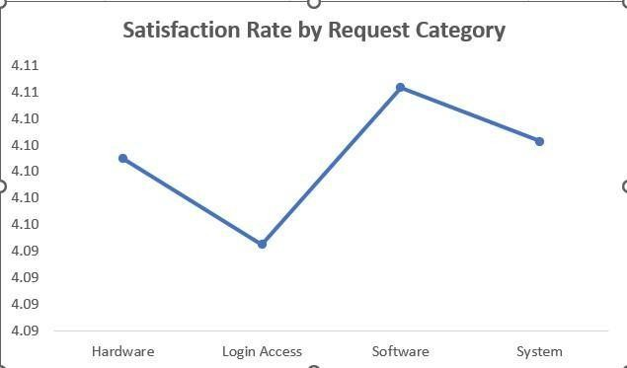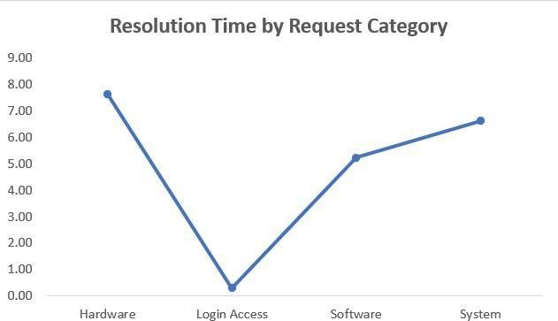

|  |  |  |  |  |  |
| --- | --- | --- | --- | --- | --- |
| **Count of ID Ticket** | **PRIORITY** |  |  |  |  |
| **SEVERITY** | **0 - Unassigned** | **1 -**  **Low** | **2 -**  **Mid** | **3 -**  **High** | **Grand**  **Total** |
| 0 - Unclassified | 115 | 80 | 55 | 106 | 356 |
| 1 - Minor | 626 | 549 | 407 | 676 | 2258 |
| 2 - Normal | 26826 | 15282 | 14468 | 32080 | 88656 |
| 3 - Major | 1434 | 614 | 713 | 2075 | 4836 |
| 4 - Urgent | 409 | 169 | 202 | 612 | 1392 |
| **Grand Total** | **29410** | **16694** | **15845** | **35549** | **97498** |

1. How has the performance of the IT support team changed over time (e.g., monthly or quarterly)?

Ans:

# Approach

The trend analysis focused on quarterly resolution times and satisfaction rates from 2016 to 2020 to identify performance fluctuations, patterns, and seasonal impacts. This evaluation aimed to highlight team consistency, pinpoint challenges, and provide actionable strategies.

# Insights

* **Resolution Times:** Resolution times remained steady at 4.5–4.6 days, with only minor fluctuations like a peak in Q2 2018 (4.7 days), likely due to increased workload or inefficiencies.
* **Satisfaction Rates:** Satisfaction improved slightly from 4.0 in 2016 to 4.2 in 2020, reflecting better service quality despite consistent resolution times.
* **Correlations:** Improved satisfaction despite stable resolution times suggests effective communication and service quality. Fluctuations in certain quarters, like Q2 2018, may relate to seasonal workload increases.

# Conclusion

Resolution times have remained stable, indicating consistent performance, though improvement may require additional resources or tools.

Satisfaction rates show gradual improvement, demonstrating employee satisfaction with the service. Peaks in Q2 2018 highlight potential impacts from seasonal factors like ticket volume spikes.

# Recommendations

* **Efficiency During Peaks:** Investigate and address causes of increased resolution times in high-volume quarters, such as by adding staff or enhancing tools during busy periods.
* **Targeted Training:** Provide training to improve efficiency, focusing on managing increased ticket volumes and addressing seasonal variations effectively.
* **System Upgrades:** Upgrade ticket management systems to streamline workflows, reduce resolution times, and handle growing demand.
* **Satisfaction Monitoring:** Maintain quarterly feedback sessions or surveys to ensure continuous satisfaction improvement and identify emerging concerns early.

Implementing these recommendations can sustain performance levels while enhancing service quality and addressing increasing workloads.

|  |  |  |  |  |  |  |
| --- | --- | --- | --- | --- | --- | --- |
| 4.8  4.6  4.4  4.2  4  Average of Satisfaction  3.8 Rate  3.6  Average of Resolution  Time (Days) | | | | | | |
|  | tr1 Qtr3  2016 | tr1 Qtr3  2017 | tr1 Qtr3  2018 | tr1 Qtr3  2019 | Qtr1 Qtr3  2020 |  |



3.4

1. If we invest more on tech (Hardware, software, etc), do you think it will improve the ticket resolution times and employee satisfaction?

Analysis: Use historical data to project potential improvements.

Ans:

# Approach

* Historical Analysis: Analyzed resolution times and satisfaction rates across categories to identify trends and inefficiencies, particularly in high-impact areas.
* Impact Projection: Estimated potential improvements using industry benchmarks and projected reductions in resolution times through targeted investments.
* Correlation Assessment: Assessed the relationship between resolution times and satisfaction rates, focusing on categories with the highest delays for improvement opportunities.

# Insights

* Resolution Times: Login Access is the most efficient category (0.3 days), while Hardware faces delays (7.6 days) due to resource or dependency issues. Software and System also have room for improvement, with averages of 5.2 and 6.6 days.
* Satisfaction Rates: Satisfaction remains steady at 4.1 despite varied resolution times, suggesting other factors like communication and resolution quality play a key role.
* Ticket Volume: System (39,002 tickets) and Login Access (29,193 tickets) dominate ticket volume, so even minor efficiency gains in these areas can significantly impact overall performance.

# Conclusion

Investments in technology and process optimization can reduce resolution times for categories like Hardware, Software, and System. However, improving satisfaction will also require enhancements in communication and resolution quality, as resolution time alone isn’t the sole driver of satisfaction.

# Recommendations

* Prioritize High-Impact Areas: Focus resources on categories with high resolution times (Hardware and System) and automate repetitive processes like diagnostics.
* Enhance Communication: Provide regular updates to employees about ticket progress to improve their experience and satisfaction.
* Collect Feedback: Use qualitative feedback loops to identify non-time-related factors affecting satisfaction and address them effectively.
* Track Metrics: Monitor KPIs such as First Contact Resolution (FCR) and Mean Time to Resolution (MTTR) to measure ongoing improvements.
* Pilot Scalable Solutions: Test new tools or processes in smaller units before rolling them out across the organization to ensure effectiveness and scalability.

These actions can streamline resolution processes, improve satisfaction, and drive overall efficiency in IT support operations.

|  |  |  |
| --- | --- | --- |
| **Request Category** | **Average of Resolution Time (Days)** | **Average of Satisfaction Rate** |
| Hardware | 7.63 | 4.10 |
| Login Access | 0.31 | 4.09 |
| Software | 5.24 | 4.11 |
| System | 6.62 | 4.10 |
| **Grand Total** | **4.55** | **4.10** |

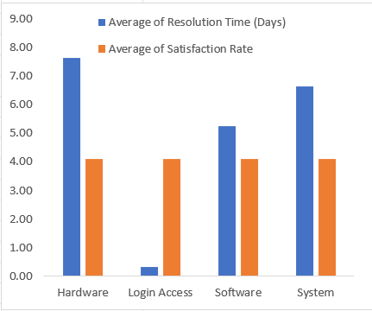

|  |  |
| --- | --- |
| **Request Category** | **Count of ID**  **Ticket** |
| Hardware | 9733 |
| Login Access | 29193 |
| Software | 19570 |
| System | 39002 |
| **Grand Total** | **97498** |

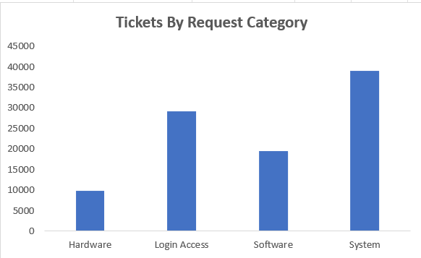

1. What are the key performance metrics for IT agents, and how can they be improved, do we need to fire any agents?

Analysis: Define and analyze metrics such as average handling time, satisfaction scores, and number of tickets resolved.

Ans:

# Approach

* **Key Metrics:** Assessed agent performance using Resolution Time (efficiency), Satisfaction Rate (service quality), and Ticket Volume (workload).
* **Analysis Objectives:** Identified underperforming and excelling agents, pinpointed improvement areas, and evaluated the need for interventions such as training or replacement.
* **Data-Driven Insights:** Compared agent performance metrics to highlight outliers, inefficiencies, and correlations between resolution speed and satisfaction.

# Insights

* **Resolution Times:** Agent 18 excels with the shortest resolution time (4.7 days), while Agents 7, 25, and 28 (5.3–5.5 days) need improvement.
* **Satisfaction Rates:** Agent 14 has the highest satisfaction rate (4.09), while Agents 25 and 28 lag behind at 3.6, reflecting user dissatisfaction.
* **Ticket Volume:** Ticket volumes are balanced (~1,900 tickets per agent), ruling out workload as a performance factor.

# Conclusion

* Resolution time and satisfaction rate are critical performance indicators.
* Agents 7, 25, and 28 are underperforming in both metrics, negatively affecting team performance.

# Recommendations

* **Training & Development:** Offer targeted training for Agents 7, 25, and 28 to improve resolution efficiency and user interactions, focusing on soft skills and technical expertise.
* **Performance Monitoring:** Regularly review agents’ metrics and use dashboards for real-time tracking to address issues proactively.
* **Process Enhancements:** Adopt best practices from high performers and introduce automation tools to support struggling agents.
* **Retention vs. Replacement:** Retain underperforming agents if training shows progress; otherwise, replace them after a probation period to sustain team performance.

|  |  |  |  |
| --- | --- | --- | --- |
| **Agent Id** | **Count of ID ticket** | **Average Resolution Time** | **Average Satisfaction Rate** |
| 7 | 1935 | 5.52 | 3.98 |
| 14 | 1942 | 4.90 | 4.09 |
| 18 | 1892 | 4.73 | 3.99 |
| 25 | 1906 | 5.20 | 3.60 |
| 28 | 1946 | 5.41 | 3.61 |

1. How do employee demographics (e.g., department, seniority) impact satisfaction and ticket outcomes?

Analysis: Segment analysis using filters and pivot tables.

Ans:

# Approach

* **Segment Demographics:** Analyze satisfaction rates and resolution times across age groups to uncover trends.
* **Correlation Analysis:** Examine relationships between age groups, resolution times, and satisfaction.
* **Outcome Assessment:** Identify age groups facing longer resolution times or lower satisfaction.
* **Recommendation Framework:** Propose targeted interventions to address demographic-specific challenges.

# Insights

* **Ticket Volume:** The 40-43 group generates the most tickets (~21,374), while the 52-55 group submits the least (~7,895).
* **Satisfaction Rates**: The 52-55 group has the highest satisfaction (4.40), while the 48-51 group records the lowest (3.99).
* **Resolution Times:** The 36-39 (4.82 days) and 44-47 (4.78 days) groups experience the longest resolution times, while the 52-55 group enjoys the fastest (3.98 days).
* **Metric Correlation:** Faster resolution times generally align with higher satisfaction, as seen in the 52-55 group.

# Conclusion

* **High-Satisfaction Groups:** The 28-31 (4.24) and 52-55 (4.40) groups show higher satisfaction compared to others.
* **Low-Satisfaction Groups:** The 32-35 (4.02), 40-43 (4.02), and 48-51 (3.99) groups face lower satisfaction, possibly linked to slower resolutions.
* **Key Observations:** High ticket volumes in the 40-43 and 28-31 groups may require extra resources to maintain efficiency and service quality.

# Recommendations

* **Resource Allocation:** Deploy more resources or prioritize tickets from the 40-43 and 28-31 groups to avoid overload.
* **Process Improvements:** Investigate delays affecting the 36-39 and 44-47 groups to improve resolution efficiency.
* **Feedback Collection:** Conduct focused surveys with the 32-35, 40-43, and 48-51 groups to address dissatisfaction issues.
* **Proactive Support:** Provide self-service tools or workshops for high-volume groups to empower them and reduce ticket demand.
* **Monitor & Adapt:** Track satisfaction and resolution times by age group to refine strategies based on outcomes.

|  |  |  |  |
| --- | --- | --- | --- |
| **Row Labels** | **Count of ID Ticket** | **Average of Resolution Time (Days)** | **Average of Satisfaction Rate** |
| 28-31 | 17501 | 4.42 | 4.24 |
| 32-35 | 11801 | 4.62 | 4.02 |
| 36-39 | 11650 | 4.82 | 4.09 |
| 40-43 | 21374 | 4.59 | 4.02 |
| 44-47 | 19569 | 4.78 | 4.04 |
| 48-51 | 7708 | 4.25 | 3.99 |
| 52-55 | 7895 | 3.98 | 4.40 |
| **Grand Total** | **97498** | **4.55** | **4.10** |

1. Identify the trends for IT support operations based on ticket volumes and satisfaction, and mention the peak and stable times?

Analysis: Use pivot tables and charts to identify peak and off-peak hours.

Ans:

# Approach

To identify trends in IT support, the analysis will focus on:

* **Ticket Volumes:** Evaluate yearly and quarterly trends to spot peak times and seasonal changes.
* **Satisfaction Rates:** Examine satisfaction trends to see how ticket volumes affect service quality.

Goal: Identify peak and stable periods to optimize IT support operations.

# Insights

* **Ticket Volume Growth:** A steady rise in ticket volumes suggests growing demand, peaking in 2020, with a 123% increase compared to 2016.

# Peak and Stable Times:

* 1. **Peak:** Quarters 3 and 4, particularly Q4 of 2020, saw the highest

volumes (7,684 tickets).

* 1. **Stable:** Quarters 1 and 2 have lower volumes, offering opportunities for proactive improvements.
* **Satisfaction Trends:** Despite rising volumes, satisfaction has slightly improved, suggesting IT support's effective adaptation.

# Conclusion

* **Key Observations:** Ticket volumes doubled over the years, with a significant 2020 increase. Satisfaction remained steady or improved, even during peak periods.

2016

2017

2018

* **Potential Risks:** Continued volume growth could strain IT operations, affecting satisfaction if not manage proactively.

# Recommendations

* **Optimize Resource Allocation:** Increase resources during peak periods (Q3 and Q4) and use stable periods (Q1 and Q2) for training and system improvements.
* **Enhance Automation:** Implement AI-driven systems and self-service tools to manage peaks efficiently.
* **Monitor Satisfaction Rates:** Conduct surveys after high-volume periods to identify and address pain points.
* **Analyze 2020 Spike:** Investigate the 2020 spike to assess if it reflects long- term trends or temporary factors, and plan resources accordingly.
* **Proactive Measures:** Use historical data to predict and address ticket spikes and common issues.

**Ticket volumes at different times**

Qtr3

Qtr1

Qtr3

Qtr1

Qtr3

Qtr1

Qtr3

Qtr1

Qtr3

Qtr1

0

2000

4000

6000

8000

10000

2019

2020

1. What metrics should be included in the final dashboard to provide a comprehensive view of call center performance and guide investment decisions?



**Satisfaction Rate at different times**

4.25

4.20

4.15

4.10

4.05

4.00

3.95

3.90

3.85

3.80

2016

2017

2018

2019

2020

Qtr1

Qtr2 Qtr3 Qtr4 Qtr1 Qtr2 Qtr3 Qtr4 Qtr1 Qtr2 Qtr3 Qtr4 Qtr1 Qtr2 Qtr3 Qtr4 Qtr1

Qtr2

Ans:

# Approach

The analysis focuses on key metrics like ticket volume, resolution time, customer satisfaction, service efficiency, and staffing. By tracking these metrics across various filters (year, quarter, department, agent, etc.), we aim to identify trends, efficiency gaps, and areas requiring resource allocation or improvement to optimize IT support operations.

# Insights

Ticket volume has been growing steadily, with peaks in certain quarters indicating high-demand periods. Resolution times and satisfaction rates reveal that there are bottlenecks affecting efficiency, especially for specific agents or departments. Additionally, customer satisfaction varies across ticket types, indicating targeted improvement areas for service quality.

# Conclusion

Key operational areas include ticket resolution efficiency, customer satisfaction, and workload balance. Identifying trends in ticket volume and resolution time across demographics or departments provides insight into where support resources are needed most. Peak periods require targeted staffing and training to maintain service quality.

# Recommendations

Allocate resources during peak periods to ensure quicker resolution times. Invest in automation to improve efficiency and reduce costs. Use performance dashboards to monitor agents' effectiveness and satisfaction levels. Regularly analyze satisfaction feedback and workload distribution to ensure proactive improvements in service quality.

